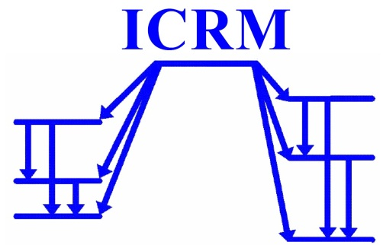
INTERNATIONAL COMMITTEE FOR RADIONUCLIDE METROLOGY
Brian Zimmerman, President
NIST -National Institute of Standards and Technology,
100 Bureau Dr., Gaithersburg, MD 20899-8462 USA
Tel: +1 301 975 4338 • • e-mail: Brian.Zimmerman@NIST.gov
Denis Glavič-Cindro, Secretary
Ježef Stefan Institute, Jamova 39, 1000 Ljubljana, SLOVENIA
Tel.: +386 1 4773 293 • e-mail: Denis.Cindro@ijs.si
http://physics.nist.gov/ICRM/

Ljubljana and Gaithersburg, 17 June 2020
Ref: DGC/ICRM Sec/2020/03

In Memory of Krzysztof Pochwalski

Dear ICRM members,
It is our sad duty to inform you that our dear colleague Krzysztof Pochwalski passed away earlier this month at the age of 89.
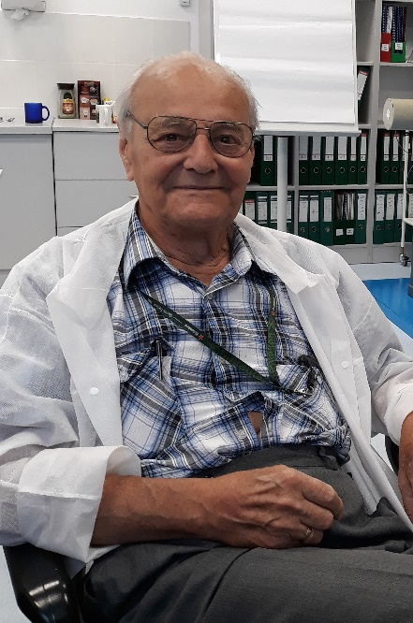
From the 1950s, Krzysztof worked at the Institute of Nuclear Research (IBJ), and then at the Radioisotope Centre POLATOM being a part of the Institute of Atomic Energy in Świerk, Poland. He actively participated in the creation of the metrological laboratory at the IBJ in Poland and was involved in the design of various radiation detectors, including coincidence scintillation devices with electronic systems. In 1979, Krzysztof constructed a triple LS-detector with a coincidence counting system. He defined a specific extrapolation parameter in the triple LS-detector based on the parallel registration of two streams of coincident pulses of various probabilities and formulated an innovative absolute measurement method for pure beta-emitting radionuclides. He christened this the “triple-to-double coincidence method” or TDCR. It was his great achievement, presented as a doctoral dissertation. In 1982, during a 2-year stay in France, he implemented the TDCR method at the Laboratoire National Henri Becquerel (LNHB) in Saclay. He highly valued cooperation in developing the method with Robert Vatin, Jacques Bouchard and Bruno Chauvenet from the LNHB laboratory. He said that his stay in France was one of his most important life experiences.
All ICRM members recognize the significant contributions that Krzysztof made to the field of radionuclide metrology during many years and the bond of friendship that linked all of us to him.
On behalf of the ICRM Executive Board and all ICRM members, we sent a condolence letter to his family and his colleagues at the National Centre of Nuclear Research.

Kind regards,

Denis Glavič-Cindro Brian Zimmerman
(ICRM Secretary) (ICRM President)

