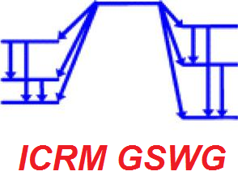
Meeting of the ICRM Gamma Spectrometry Working Group
October 29-30, 2020 from 12:00 to 15:00 UTC (13:00 to 16:00 CET)
PRELIMINARY AGENDA
Please suggest your scientific contributions* (recent studies, information of interest to share, etc.) and discussion topics** through the registration form.
October 29 th:
12:30 – 13:00 Tests for access to the webconference
13:00 – 13:15 Welcome and workshop objectives (M.-C. Lépy)
13:15 – 14:45 4-6 contributed* talks (10 to 20 minutes)
14:45 – 14:55 Short break
14:55 – 15:30 2-3 contributed talks
15:30 – 16:00 Proposal of new actions - Discussion** (all participants)

October 30 th:
12:45 – 13:00 Tests for access to the webconference
13:00 – 13:15 Presentation of the benchmark on coincidences summing (M.-C. Lépy)
13.15 - 14.50 Presentation of results by code (10-15 minutes)
14:50 – 15:00 Short break
15.00 – 15:30 Summary and discussion – further step(s) (all participants)
15:30 – 16:00 Proposal of new actions - Discussion** (all participants)

